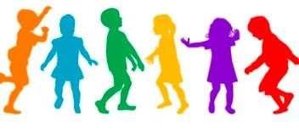

**What to do if your child is a close contact of Covid**

**-**

**in**

**19**

**school or childcare**

**The risk to your child is low**

Children of any age can get Covid

-

19

coronavirus) but they seem to get it less

(

often than adults do.

**The health and safety of all children and**

**staff in the school is our highest priority**

**in the**

**Schools’ Public Health Team.**

**The**

**3**

**things you need to do are:**

**Children and Covid**

**-**

**19**

**)**

**(coronavirus**

If your child does get Covid

-

19

, they may have

:

•

no symptoms at all

*or*

•

mild symptoms

But there is a chance they could pass the infection

onto someone else. This is why we are asking you to

do 3 things please.

Keep

an eye on your child

•

This is to see if they get any symptoms of

Covid

-

like a fever, cough, shortness of

19

breath, headache, sore throat, runny nose

or changes

to their sense of taste

or smell

.

•

If they do get symptoms keep them away

from others in the house and contact your

GP who

may

arrange a

swab.

•

If your child

**has symptoms**

others

in your

home should not go to

work,

school

or

childcare until

the results are back.

Restrict

your child’s

movements

•

Keep them at home.

•

Don’t send them to school or childcare.

•

Don’t let them visit other people’s homes

.

•

Don’t have visitors to your home.

•

If your child

**is well**

and does not have

any Covid

-

symptoms, other people in

19

the home can still go to work and school

–

unless you are given different advice by

the Schools’ Public Health team.

Bring your child for Covid

-

19

tests

•

The

number of

tests depends

on when

your child was in contact with the person

with

Covid

-

19

. The HSE arranges these

tests.

Y

ou don’t need to ring your GP.

•

Testing is the best way to know if your

child has Covid

-

19.

•

Your child will be able to return to school if

their swab at

day 10 is negative

**and**

they

are

well.

•

Without a test at Day 10 your child will

need to restrict

movements for at least 14

days.

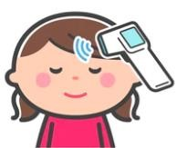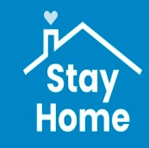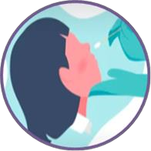

*Department of Public Health*

*–*

*Midlands (August 2021)*

HSE

Schools Covid response

team

s